Anna Phillips
9:30am section
DS 5030: Lab 1 Report: Genre Retrieval System
When I evaluated the precision@3 of raw dot product, cosine similarity, and tf-idf cosine similarity, I was surprised by how low the results were, especially for tf-idf. Only about 21% of tf-idf cosine similarity recommendations matched the correct genre, and that percentage only jumped to 23% when looking at just the #1 matches. This suggests that word count patterns and word uniqueness aren’t strong enough predictors of genre, so we need to find another variable that can aid this.
I looked at the original songs data frame to find a column that might help enhance our search for similar genre and ended up going with top_tags because they appeared to be user-written and thus would provide more subjective data for each song:
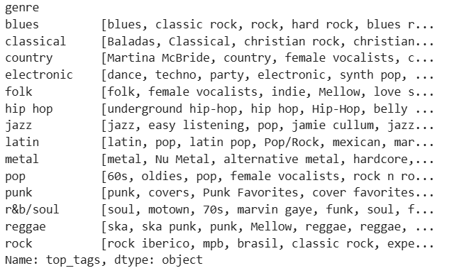
Figure 1. Initial exploration of top_tags by genre
Specifically, some tags had combined genre descriptions like “blues rock” or “Latin pop,” which would add nuance to a system that already uses tf-idf cosine similarity to match for word patterns/uniqueness. Importantly, some of the user tags used the exact genre name as a tag, which seemed a little bit like cheating since genre is our ground truth for a recommendation. Because of this, I removed any tags from a song that had an exact match for its same genre name but kept interesting ones like “blues rock” or “underground hip-hop” because sharing these niche-r terms would probably be rare and thus a potentially high-value similarity identifier. Songs were allowed to maintain basic genre tags that did not match their own (e.g., songs in the “rock” genre can have a “blues” tag, but not a “rock” tag).
To implement this idea for my genre retrieval system, I consulted ChatGPT on the easiest way to standardize the top_tag column and even helped correct its code to ensure that “r&b/soul” genre tags were properly filtered out. ChatGPT also provided a recommendation to use Jaccard similarity as a measure of comparing how tags overlap between songs (it compares two sets by dividing the number of shared elements by the total number of unique elements, giving a score between 0-1). I then researched Jaccard similarity on my own to ensure the method made sense, and I investigated the spread of top_tag sizes to confirm that there were no crazy outliers (all top_tag columns had 0-5 tags per song, which was helpful). ChatGPT also helped convert my previous tf-idf similarity code to add a Jaccard similarity calculation (and make it more efficient than my previous attempts), and I also collaborated with it to include a way to change the weights, so that I could experiment with tf-idf cosine similarity vs Jaccard similarity holding more importance.

Sharing similar words, and going deeper to look at word patterns and word uniqueness as compared to the corpus is useful, but we’re lacking vibes.
Confirmed that the `top_tag` column had up to five tags for each song, which is helpful because it prevents songs with a lot of tags from skewing results.

To engineer a system, we need a ground truth for success or failure. In practice, we would have experts label a dataset or observe user responses and infer success or failure (success might mean they continue their session and click on one of our recommendations, and failure means their session continues but they search for new songs on their own). In the absence of a ground truth, we can use the song genre.

So your job is:

1. For every Top-40 query song, remove the query song itself and every song by the same artist before selecting the top three recommendations for raw inner product, cosine similarity, and TF-IDF-based cosine similarity. If a recommendation's genre matches the query song's genre, record a hit (`True`); otherwise record a miss (`False`). Report `hits.mean()`: this is mean **precision@3**, the share of all recommendation slots that are same-genre hits. Do not hard-code the denominator.
2. Using the ideas from step 1, try to engineer a system that outperforms the available baselines. What matters is your explanation for why you designed the system you did, not whether or not it outperforms the baselines.
3. Write up your results in a separate text file, as a report on your work as a data engineer. Do the existing options work well, or did you find ways to outperform it?

